

**SAP: Material Requirement Planning (MRP)**

Assignment 2

INFO 3240

October 15, 2017

LiWen Tan

**1. Create ##F100 (NRG-A bar) and ##F110 (NRG-B bar) Routings**

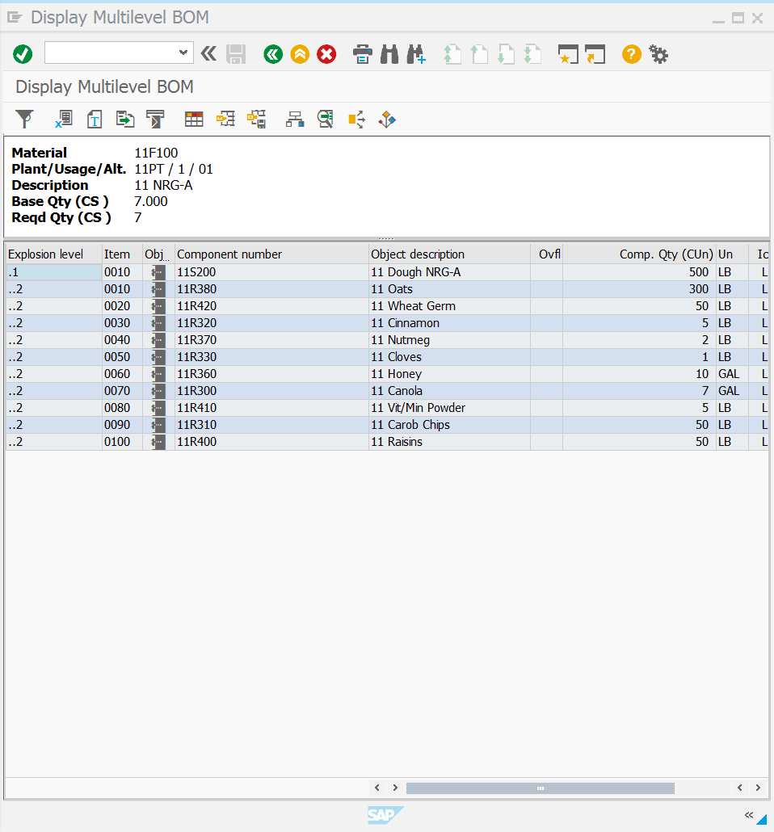

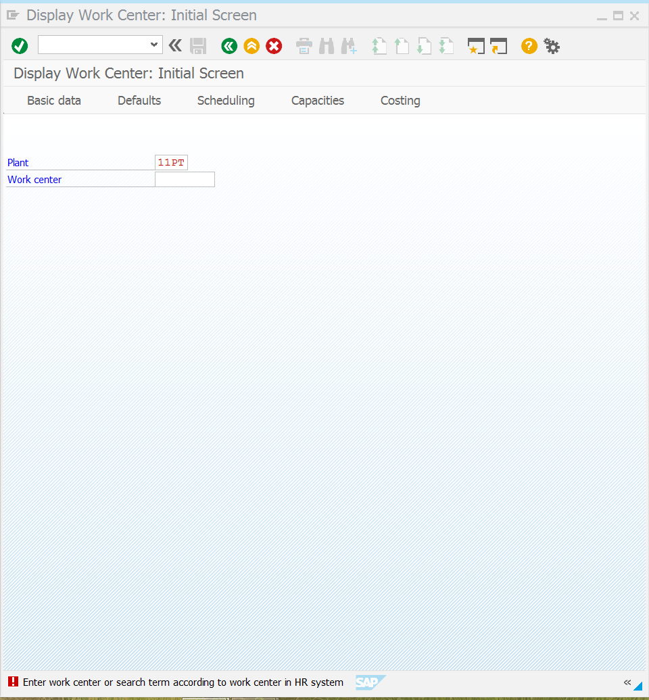

**2. Create Routings for material ##S200 (dough for NRG-A bars) and ##S210 (dough for NRG-B**

**bars)**

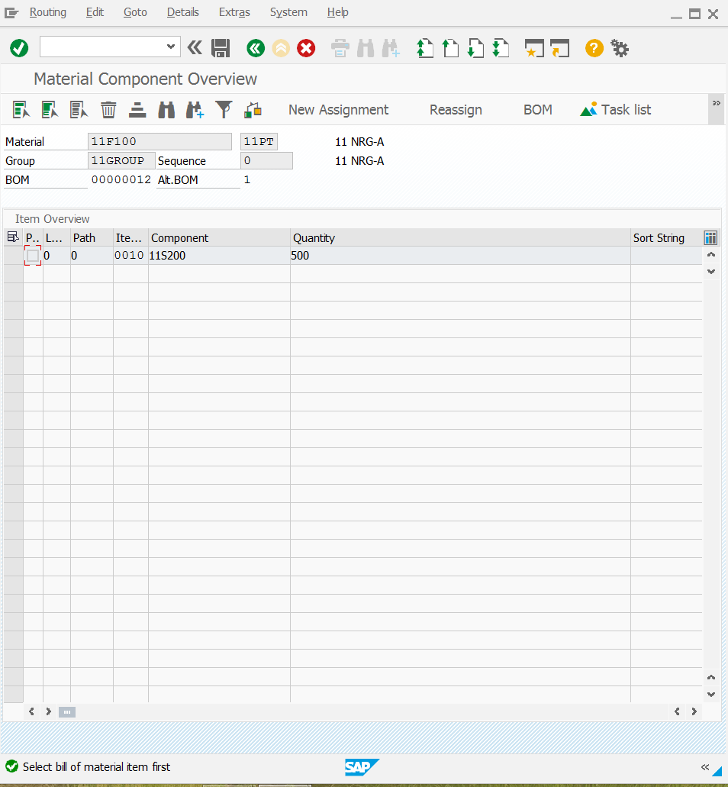

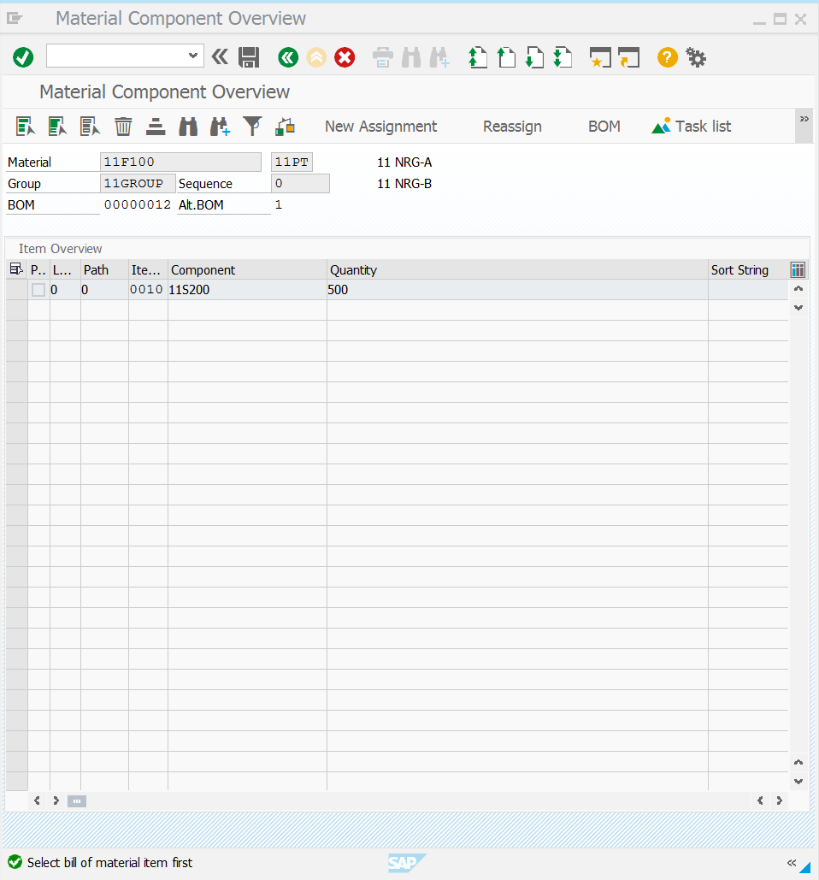

**3. Create Product Group**

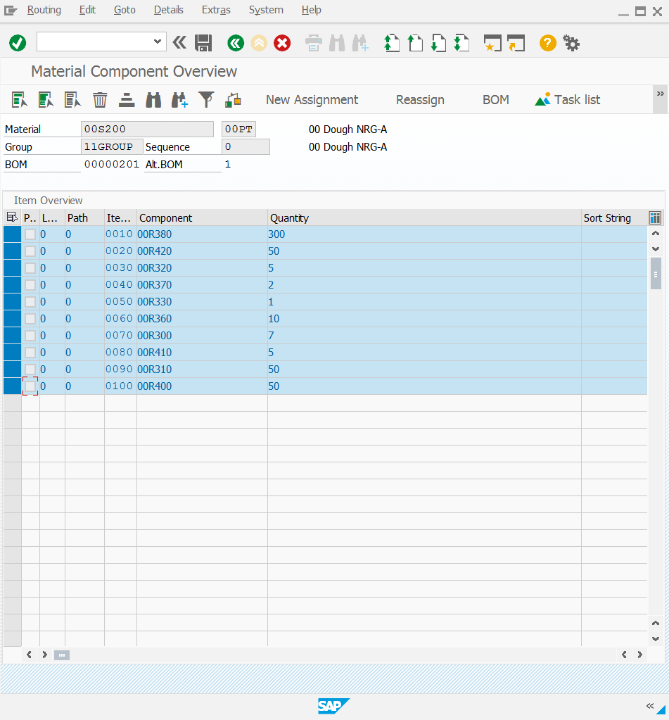

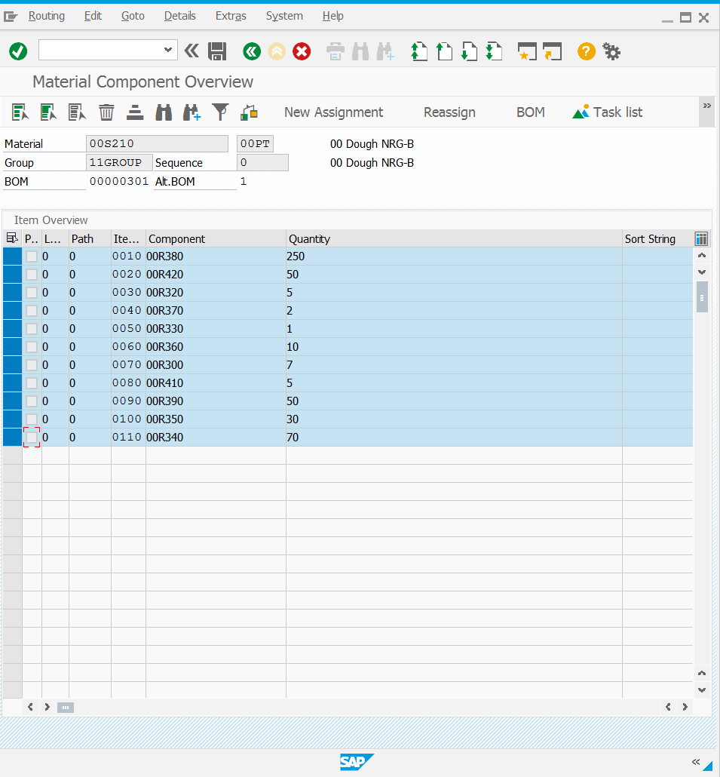

**4. Run MRP (Material Requirements Planning)**

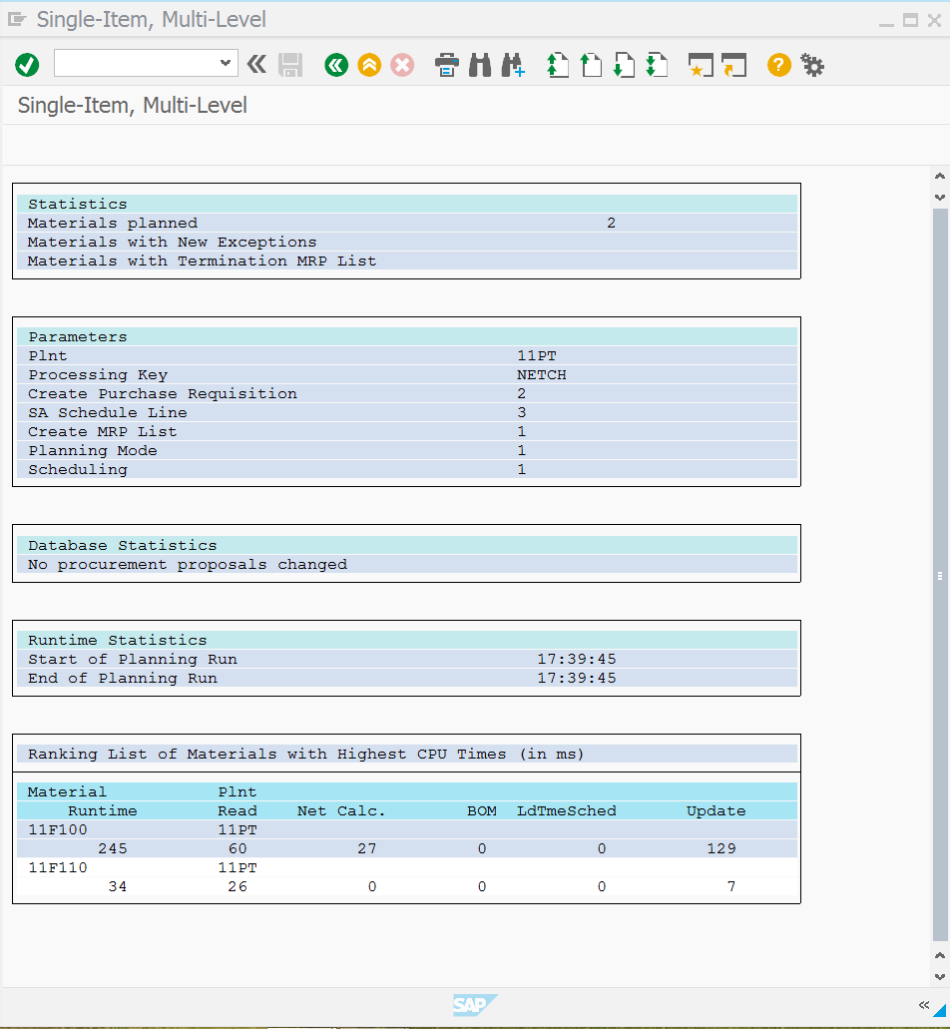

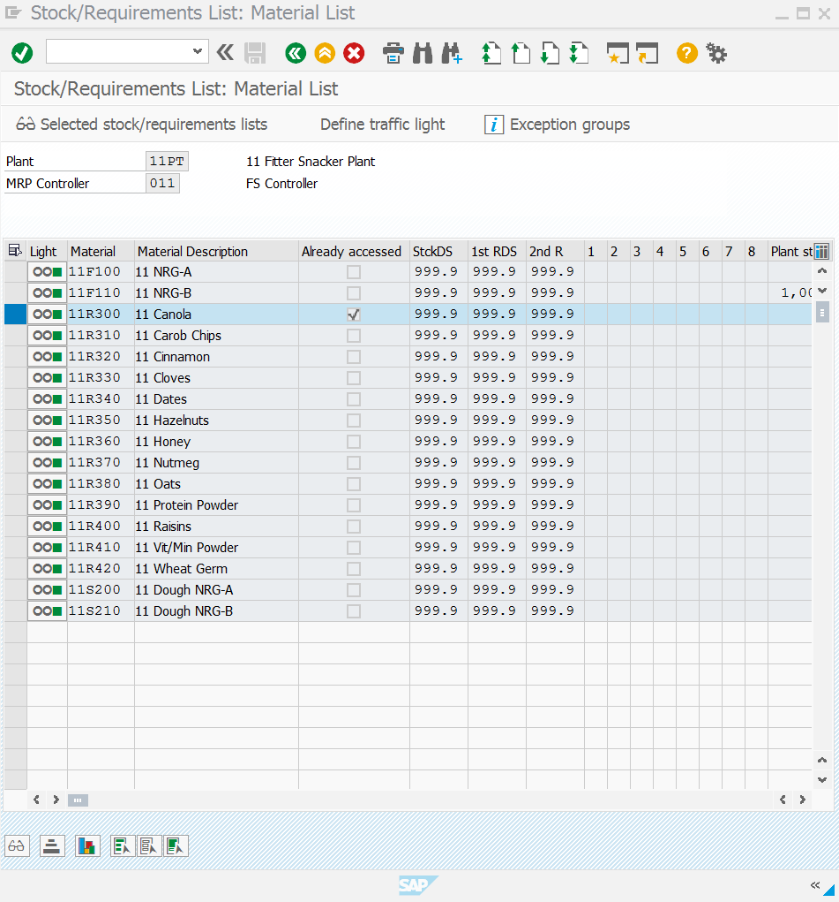

**5. Create Sales and Operations Plan**

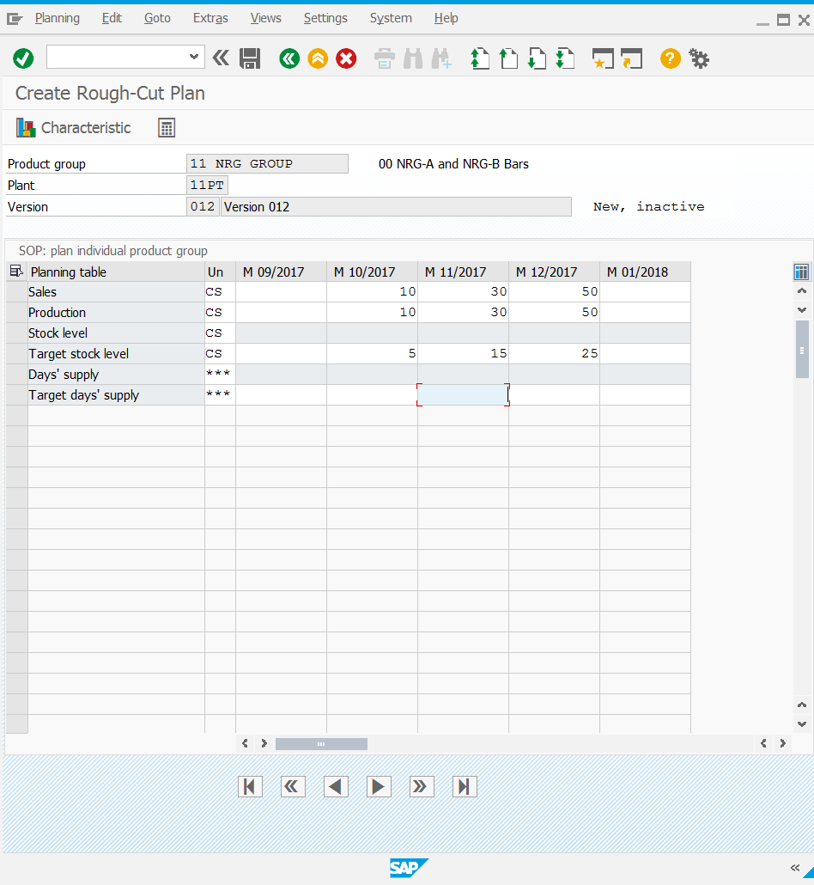

**6. Transfer Sales and Operations Plan to Products**

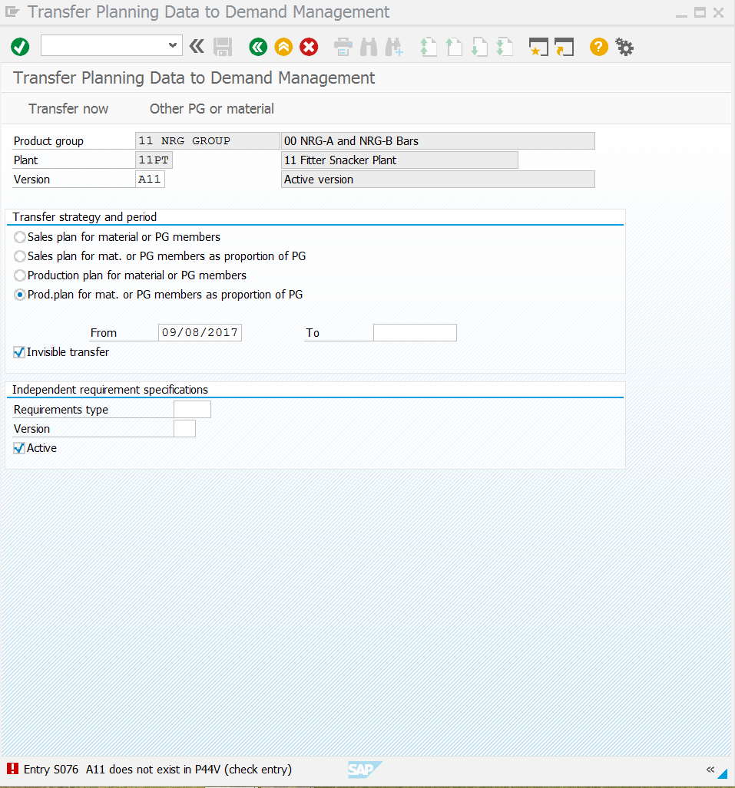

**7. Create Planned Orders with MRP**

